**Lesson 85 - 94:**

***Generative Adversarial Networks (GANs)*** are a class of neural network architectures used in machine learning and deep learning. They consist of two competing neural network models: a generator and a discriminator.

The ***generator*** creates new synthetic data, such as images, sounds, or text, trying to produce examples that are indistinguishable from real data in the training set. It learns to map input samples from a latent space to the desired data space.

The ***discriminator***, on the other hand, evaluates the authenticity of examples generated by the generator, distinguishing between real and synthetic data. It is trained to correctly classify the origin of the data as "real" or "fake."

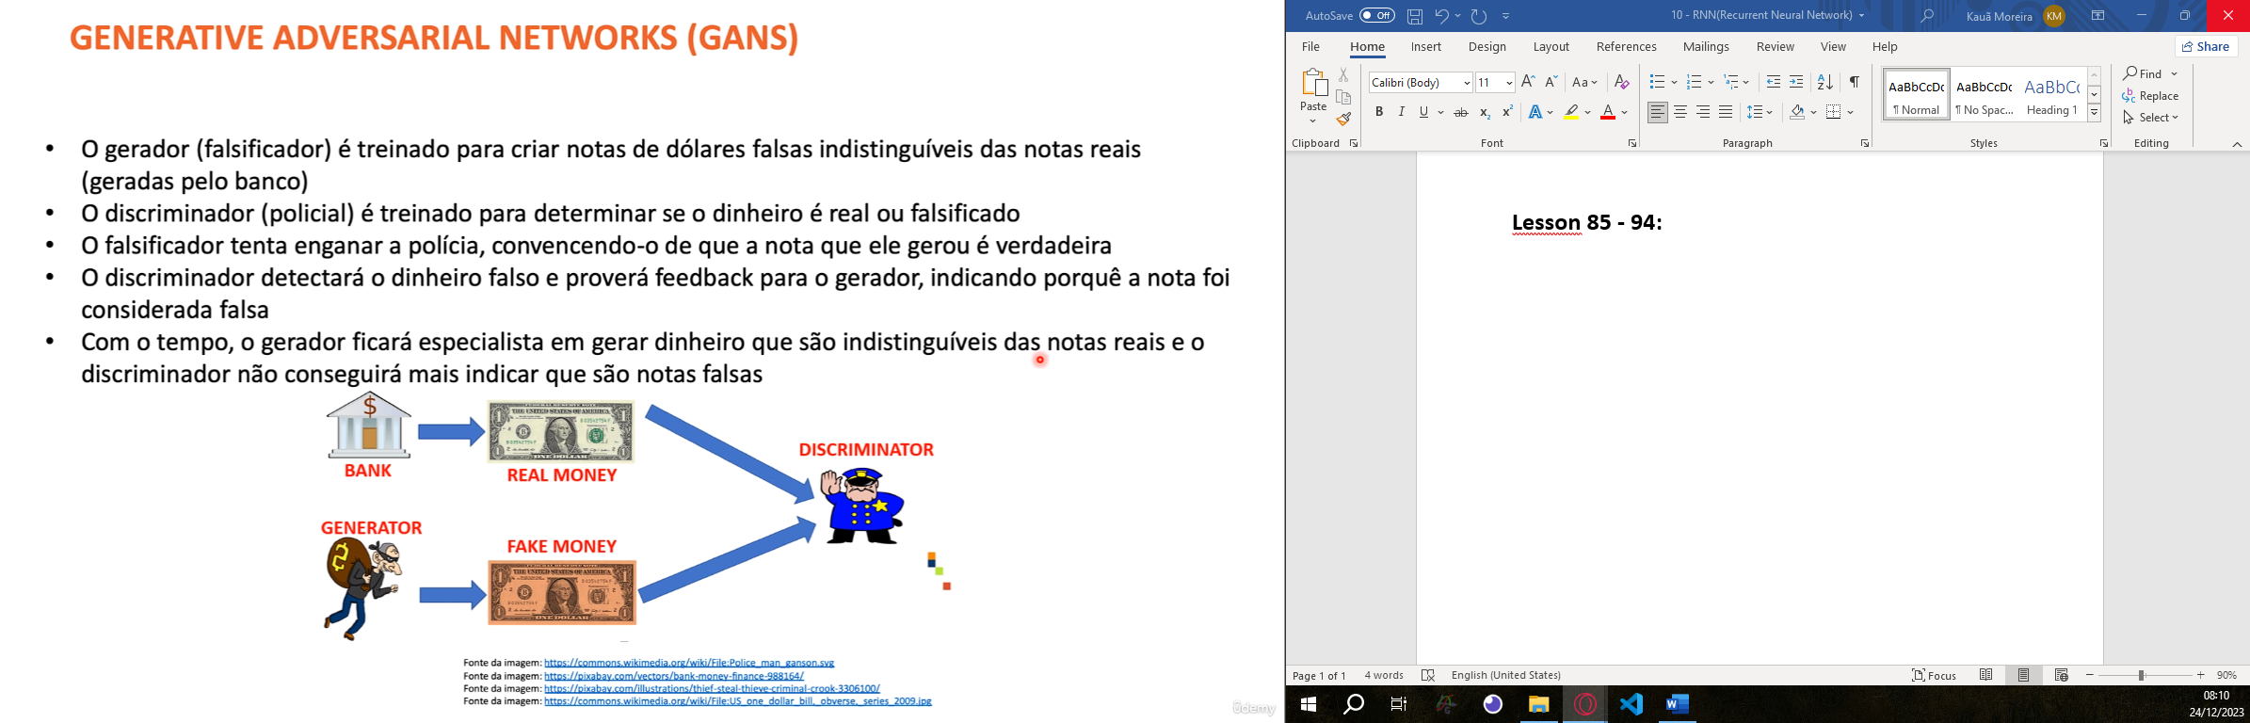

Both unities learn during the training process. Generator learn how to create better fakes information and the discriminator learn how to identify fakes information.

